Project Overview
Dragon Queue is a website designed to manage the queue for the pool table, table tennis station, and future stations in the JCR.
Many students use the JCR during their free time to relax, socialise, play pool, and play table tennis. This includes both Bethune College students and students from other colleges. During busy times, especially around the pool table, several people may be waiting to play at the same time.

Current Queue Systems

Pool Table
The pool table currently uses a whiteboard queue. Students write their names on the board and wait until the people ahead of them have finished playing.
Although the whiteboard provides some organisation, it still creates problems such as:
- Names being erased or crossed out
- Students skipping ahead in the queue.
- Disagreements about who joined first
- Students needing to stay near the area to protect or monitor their position
- The queue becoming messy or difficult to follow

Table Tennis
The table tennis station does not currently have a physical queue system.
Students usually call “next” and rely on memory to keep track of the order. This can lead to:
- Students forgetting their position.
- Multiple people claiming that they are next
- Confusion when new players arrive
- Difficulty confirming who joined first
- Disagreements between students
The original project idea was created because both systems rely heavily on memory, honesty, and students remaining physically present.

Proposed Solution
Dragon Queue would replace the current informal systems with a digital queue.
The website would record the order in which students join and display the current queue for both activities.
Students would be able to:
- Create an account or log in
- View their profile
- Select either pool or table tennis
- View the current queue
- Join or leave a queue
- See their position
- Receive a notification when their turn is approaching
The pool table and table tennis station would each have separate queues.

How the System Would Work
- A student logs into Dragon Queue.
- The student is shown the dashboard, which has an announcement, profile, pool table, and table tennis.
- The dashboard displays the current players, the number of people waiting, and a preview of the queue.
- The student selects Join Queue.
- The system records when the student joined and places them at the end of the queue.
- As games finish, the student moves closer to the front.
- When only one person remains ahead, the student receives a notification that their turn is approaching.
- Once the student reaches the front, they confirm that they are available to play.
- After their game begins, the next person moves to the front of the waiting queue.

First Prototype
The first Dragon Queue prototype would run as a closed website on one computer in the recreational space.
Starting with one computer would allow the council to:
- Test whether students understand the system.
- Observe how it performs during busy periods.
- Identify technical or organisational problems.
- Collect feedback from students.
- Adjust the queue rules before making the website available online.
The prototype would focus mainly on the essential queue features rather than advanced statistics or competitive features.

Main Website Sections

Dashboard
The dashboard would provide an overview of the recreational space, including:
- Announcements
- Pool-table information
- Table-tennis information
- Current players
- Number of people waiting
- Queue previews
- Quick access to the rules

Pool Table & Table Tennis Sections
These sections would display:
- Whether the pool table is currently occupied
- Current players
- Number of people waiting
- A preview of the pool queue
- The user’s queue position
- Join Queue and Leave Queue buttons.
- An option to view the full queue

Profile
The profile page could display:
- The student’s name
- Current queue status
- Account information
- Future game records or statistics

Rules
The rules section would show the basic rules of the games and include any house rules.

Important Rules to Decide
Before launching the system, the council would need to agree on several rules, including:
- Whether students can join both queues at the same time
- How long a student has to respond when their turn arrives
- What happens if someone misses their turn
- Whether the person is removed or moved to the back
- How doubles games would be handled
- Whether games should have time limits during busy periods
- Who is allowed to edit or correct the queue
- How queue disputes would be reported
Clear rules would help ensure that the website is used consistently.

Benefits of Dragon Queue
Dragon Queue would provide several benefits to the recreational space:
- A clear and visible queue order
- Less opportunity for queue skipping
- Fewer disagreements about who joined first
- A consistent system for both activities
- Less need for students to remain beside the tables
- Better communication when a student’s turn is approaching
- A more organized recreational environment
- A recorded joining time that can help resolve disputes
- Chance to keep track of queue from anywhere

Future Development
After the basic queue system is tested and working properly, future versions could include:
- Access from students’ technology
- A shared tablet in the recreational space
- Guest accounts
- Browser or email notifications
- Estimated waiting times
- Game timers
- Win and loss records
- Total games played
- Win percentages
- Leaderboards
- Tournament accessibility
- Support for additional recreational activities
These features would be considered after the main queue system is reliable.

Imagery:
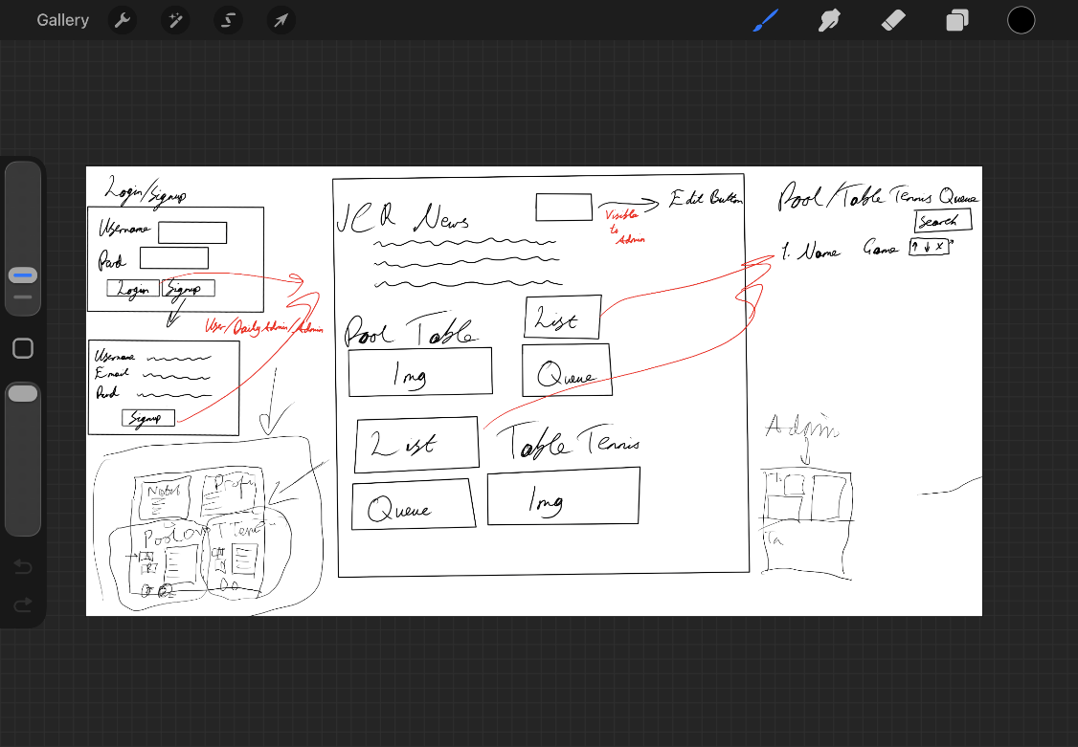
1st Design
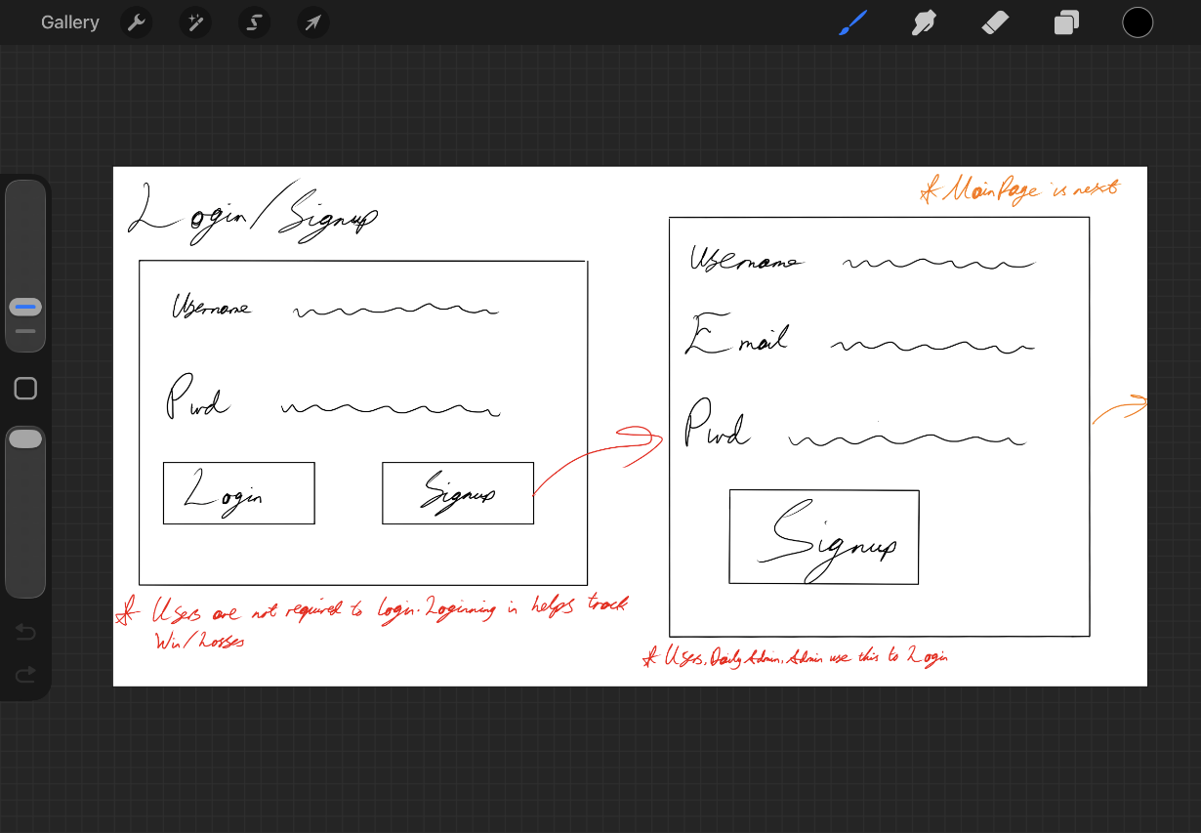
2nd Design Login
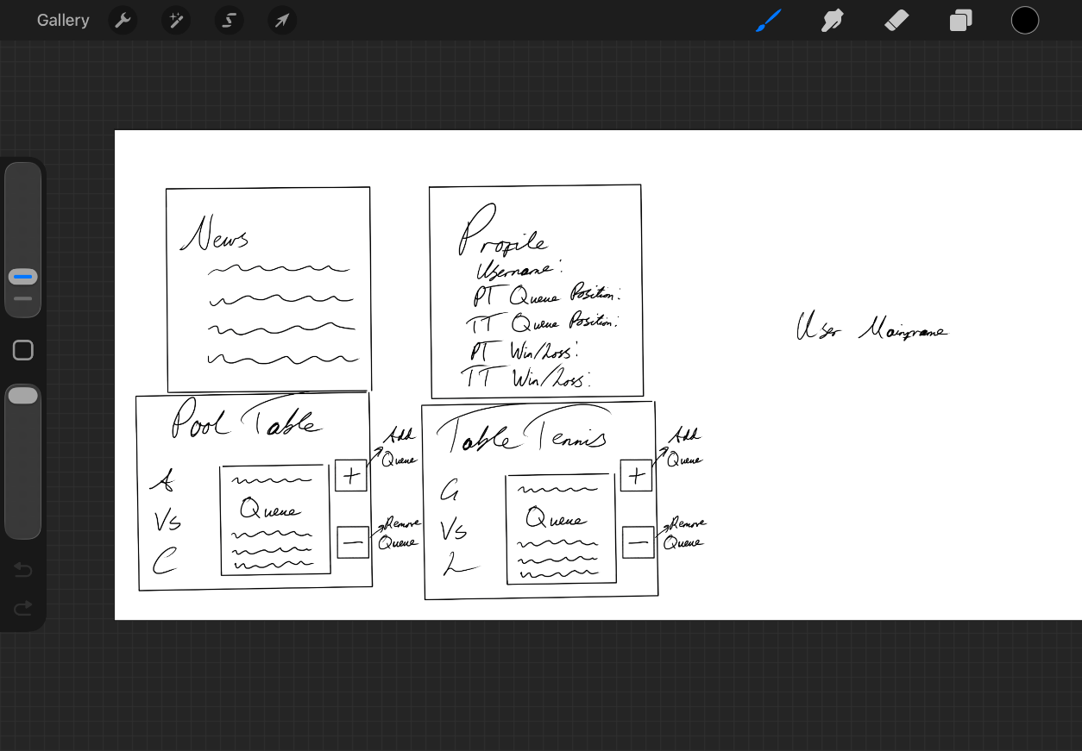
2nd Design User Dashboard
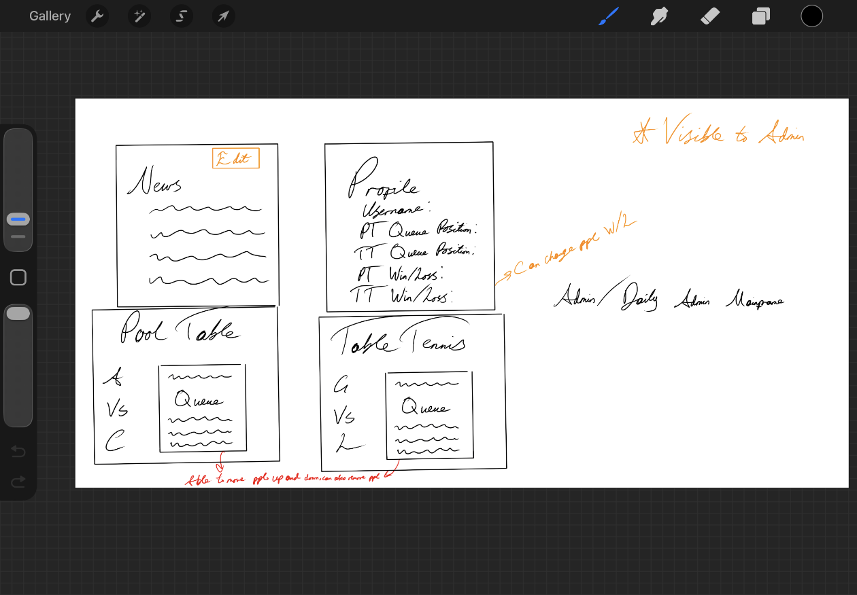
2nd Design Admin Dashboard
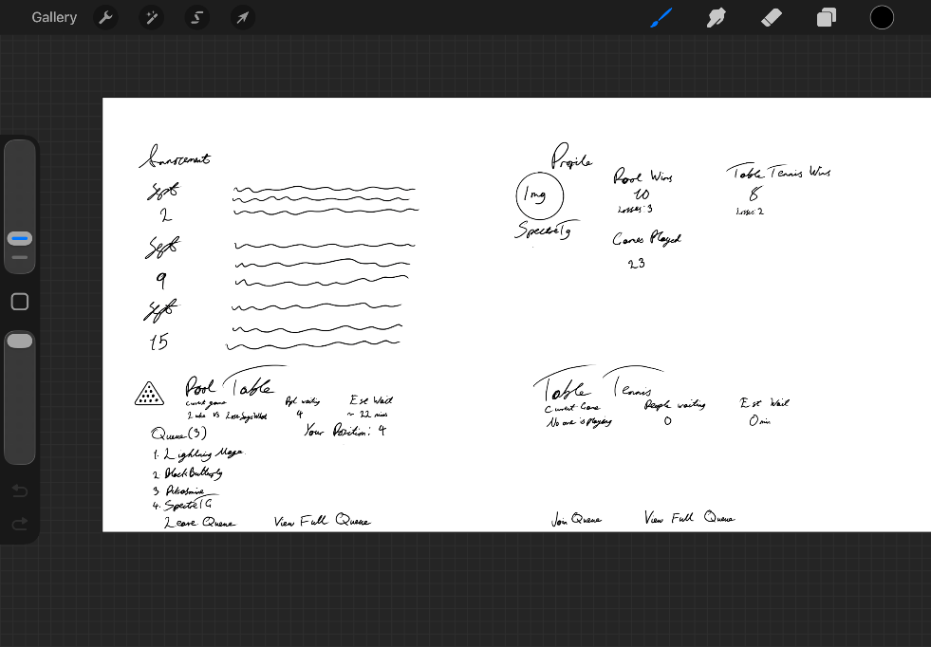
Final Design
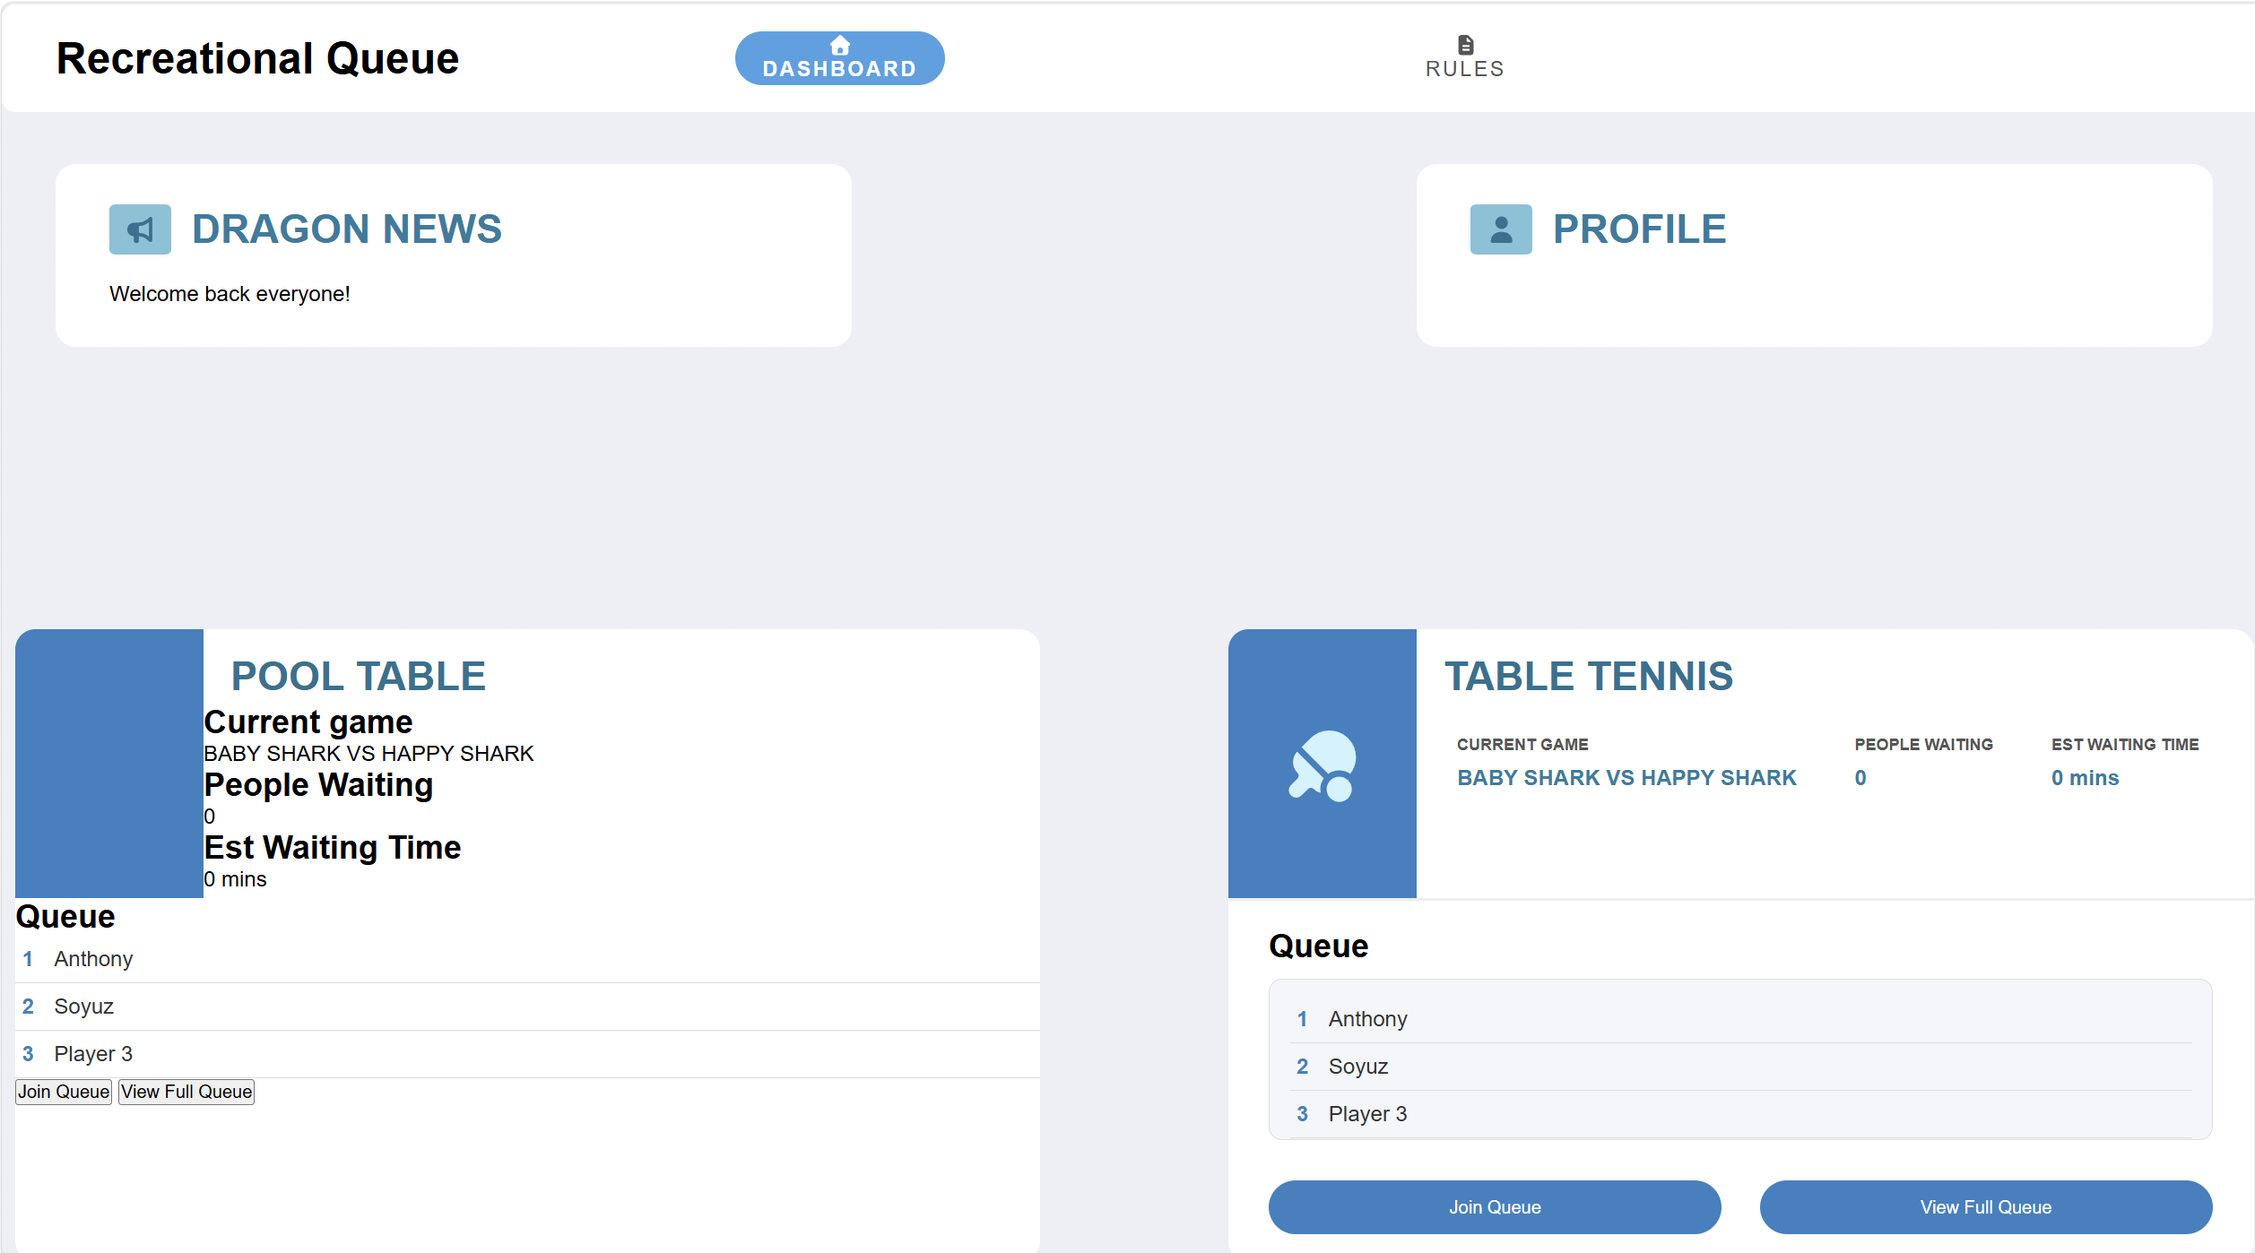
Current State of Dragon Queue

